Q1.Midterm 2014
- (5 pts)
Give the range(s) of integer keys the insertion of which would cause an immediate violation of the AVL property in nodes a,b,c,d,e,f,g,h,i,j in the AVL tree below.
- (10 pts)
Select one key to insert from within the keys in part (a) to the below AVL tree and show

redrawing the tree and explicitly stating the 1)α-node, 2)violation type and 3) correct
rotation type how the AVL property is restored.
36
18
72
12
24
54
96
32
48
64
88
58
68
40
a
b
g
i
j

h
g
f
e
c
d

Answer:

a:[25,31]; b:[33,35]; c:[37,39]; d:[41,47]; e:[55,57]; f:[59,63]; g:[65,67]; h:[69,71]; I:[73,87];J:[89,95]
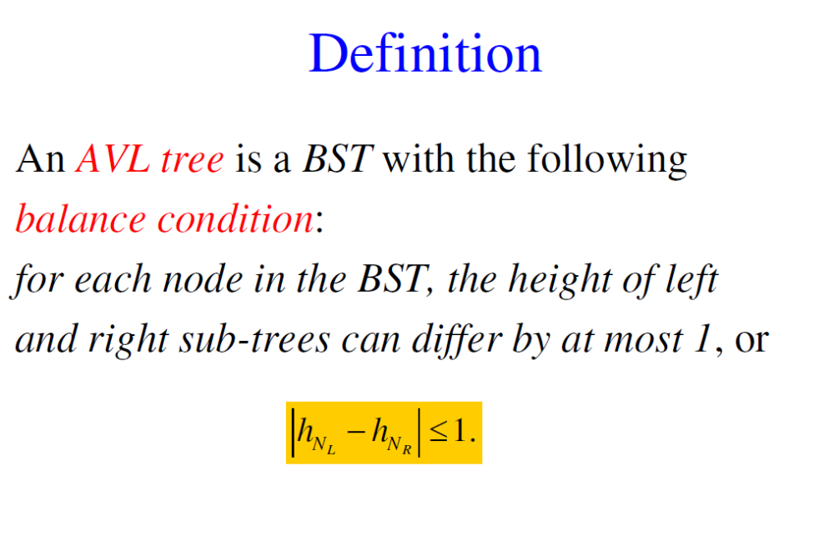
- Insert 66: α-node: 72; AVL violation: LR type; double rotation
36
18
72
12
24
54
96
32
48
64
88
58
68
40
66
α - node
RL – (AVL property is violated at 72 by inserting 66.
Child of that subtree /subtree of α - node
(Right child of Left subtree of 72 )
violation
RL,LR type
Double rotation
Rotated AVL tree
36
18
64
12
24
54
72
32
48
58
68
40
66
96
88

- Take the grandparent of new inserted node and put it into the location of α – node

- put the grandparent s left sub tree as the child of left sub tree of α – node position and put the grandparent s right sub tree as the child of right sub tree of α – node position.

Quiz-2014 (36 points)

Find 3 different type of 15-node AVL tree topologies with different Average Access Time.

For each type,

Draw the example topology (4 points)

Calculate the number of topologies (4 points)

Calculate the Average Access Time (4 points)
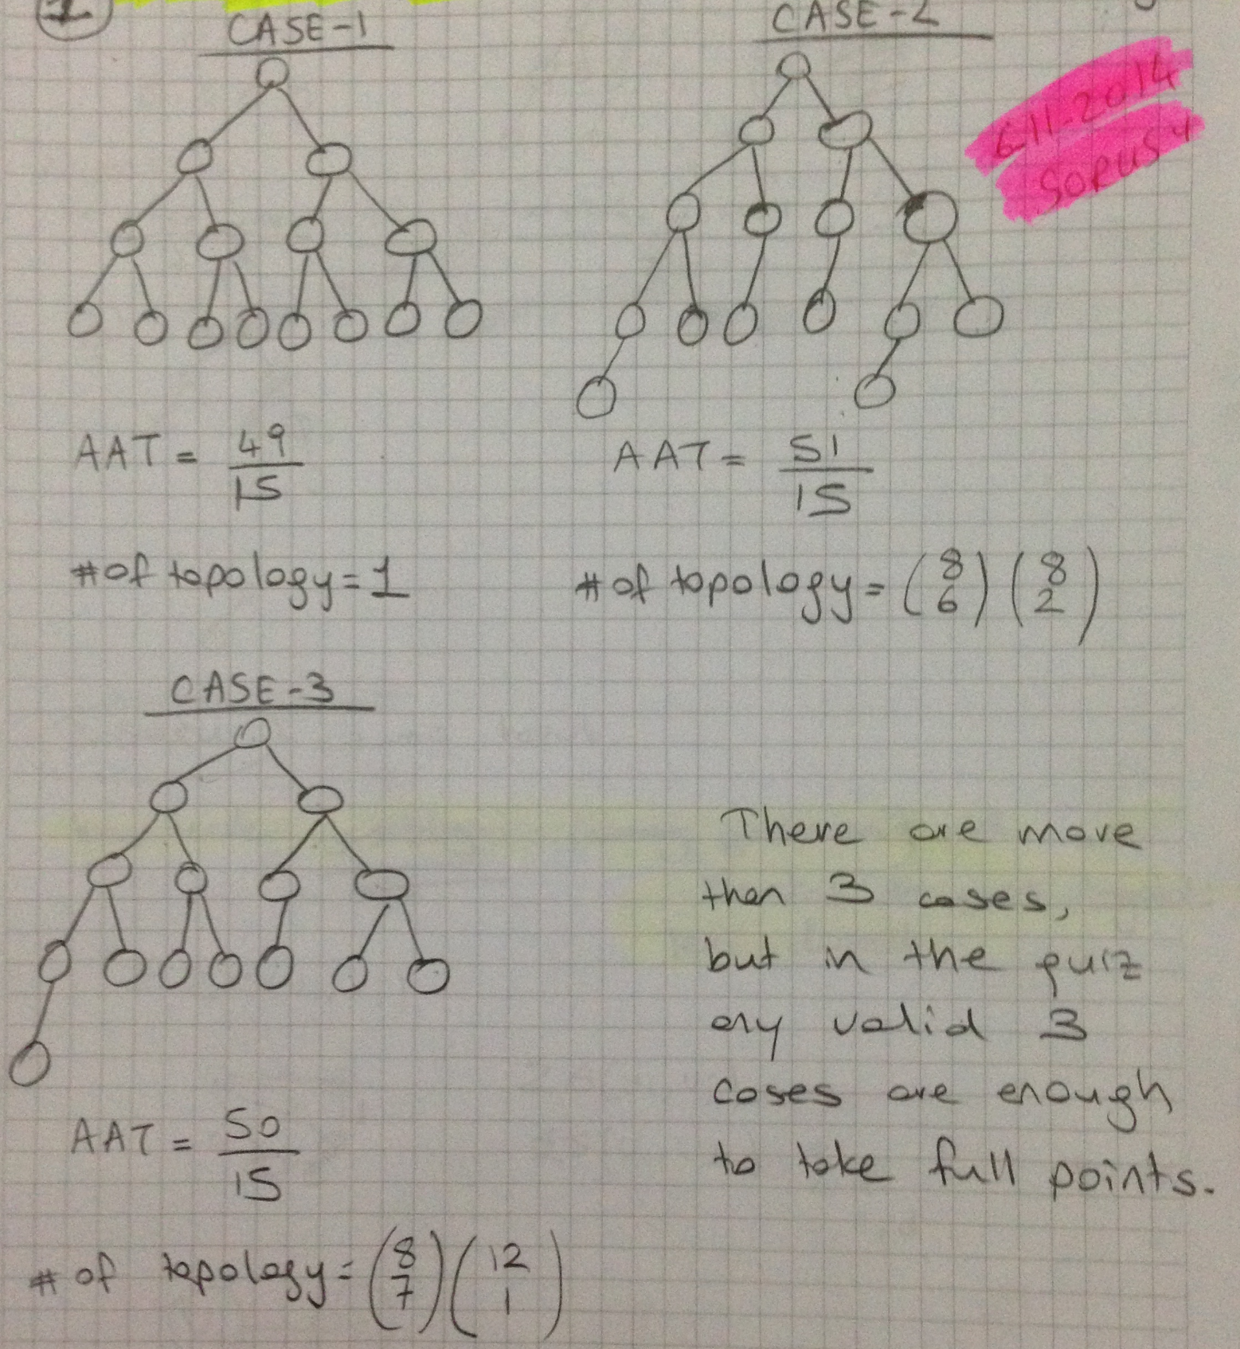

Q3. 2009 Midterm (13 + 12 = 25pts)
- Find 3 different topology groups for 20-node AVL tree topologies? Calculate the number of topologies. Show your calculations that lead to your result!
- Draw an example topology for each different average access time and state the access times!

t_{ave}=76/20=3.8 t_{ave}=75/20=3.75 t_{ave}=74/20=3.7
N=$\left({1 \atop 1}\right)\left({2 \atop 2}\right)\left({4 \atop 4}\right)\left[\left({8 \atop 7}\right)\left({12 \atop 5}\right)\left({4 \atop 1}\right)+\left({8 \atop 7}\right)\left({12 \atop 6}\right)+\left({8 \atop 8}\right)\left({16 \atop 5}\right)\right]$

Q4. Final-2015 (15+10=25pts)
- How many different 6-node BST topologies, N_{total}, are there? Draw an example topology to characterize each topology group (a topology group signifies all BST topologies with the same number of nodes at each of its depth levels) and show your calculations that lead to your result!

  - Which among those in (Q1a) are already AVL tree topologies?
  - Apply the necessary rotations, stating 1. the α-node, 2. type of problem, 3. the type of necessary rotation, only to those topologies in (Q1a) that can be converted to an AVL tree at one rotation (single or double)?

Example topologies for each topology group:

5
4
3
2
1

9
8
7
6

We calculate below the number N_{total} of different BST topologies showing the number N_{k} of topologies for topology group k where each combination 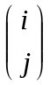 denotes j nodes of the i available positions in the specific depth level of the corresponding example topology k.

For instance, for example topology 1, the number N₁ of different topologies can be calculated as follows:
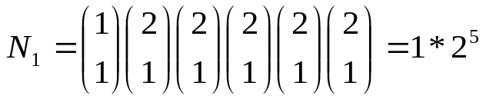

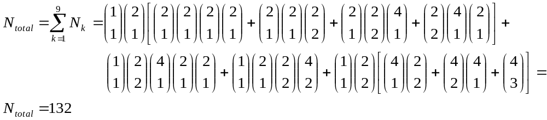We calculate N_{total} as in the following:

b)
i) The sample topology representing the topology group at 9 in (Q1a) ia already an AVL tree topology.
ii) The sample topologies for groups 6 and 8 are those that can be converted to an AVL tree topology by one rotation.
For 6)
α-node: root
Problem: LL;
Rotation: we will restore AVL property by solving the LL problem by a single rotation.

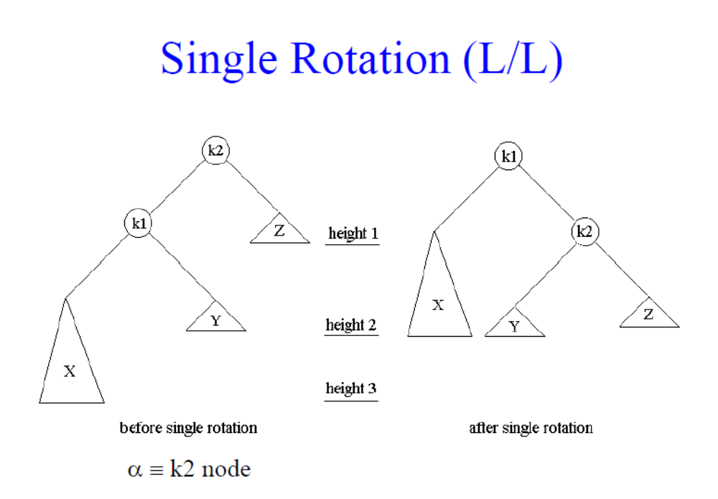
Rotating the tree in the clockwise
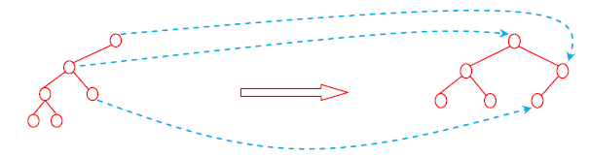

For 8)
α-node: root
Problem: LL;
Rotation: single rotation
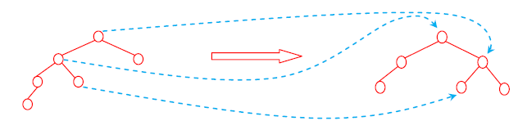

5.)Quiz-2016 Construct a BST for the following sequence. (4 points)

30, 10, 94, 3, 99, 48, 59, 100, 51, 80, 77, 85, 78

Splay the node with key ”78” (30 points)

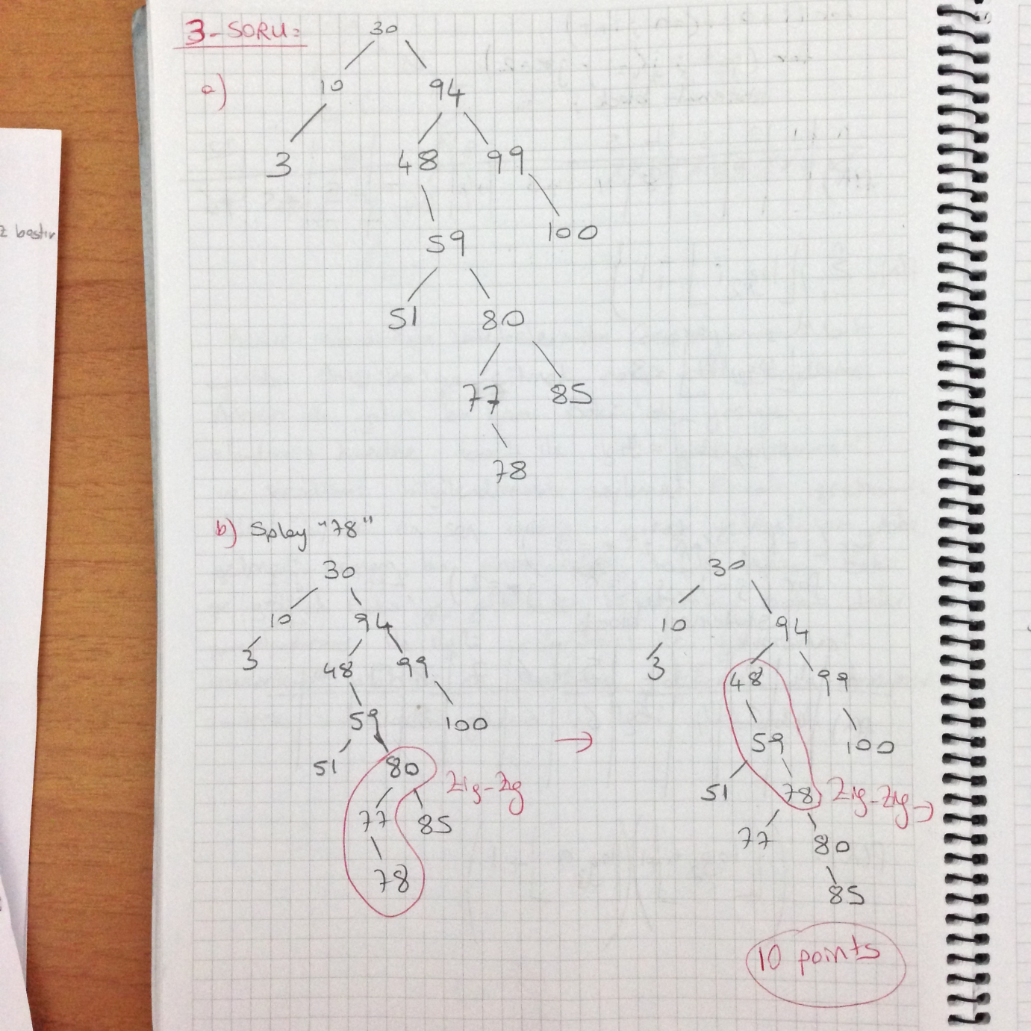
Zig-Zag , double rotation, place the grandchild into the α-node, make the parent of the grandchild the left child and make the α-node the right child of the new root of the subtree.
Zig-zig, RR violation, single rotation, make the tree clockwise reverse
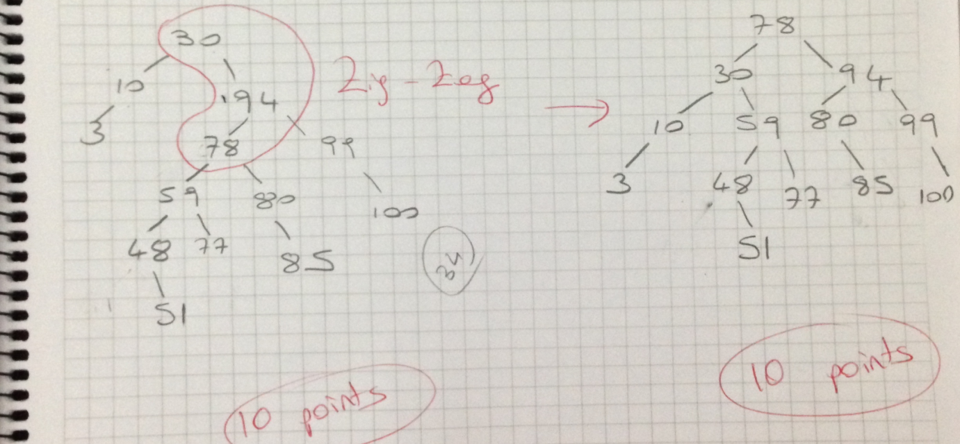
Zig-Zag , double rotation, place the grandchild into the α-node, make the parent of the grandchild the left child and make the α-node the right child of the new root of the subtree.

6.) Quiz-2015 (30 points)

Construct a BST from the letters ”MACHINE LEARNING” where no duplicate letters are allowed.

Splay the node ”L”. (Show all your work with)

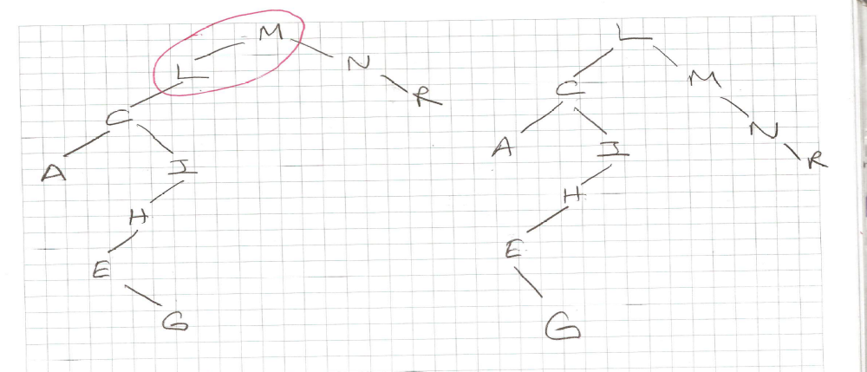

Q7. FİNAL 2014 (10+15=25pts) (HOME EXERCISE)
Assume an AVL tree topology of height 6 (from depth level 0 to 5) with a minimum number of nodes.
- How many such binary tree topologies (not only AVL tree topologies but also those ) are there provided that the number of nodes at each depth level remains constant? Show one sample AVL tree topology.

- How many binary tree topologies (NOT AVL tree topologies) are there with the same total search time or internal path length?

